AI-Powered Customer Support Chatbot
Task 1 System or Project - Level State Model
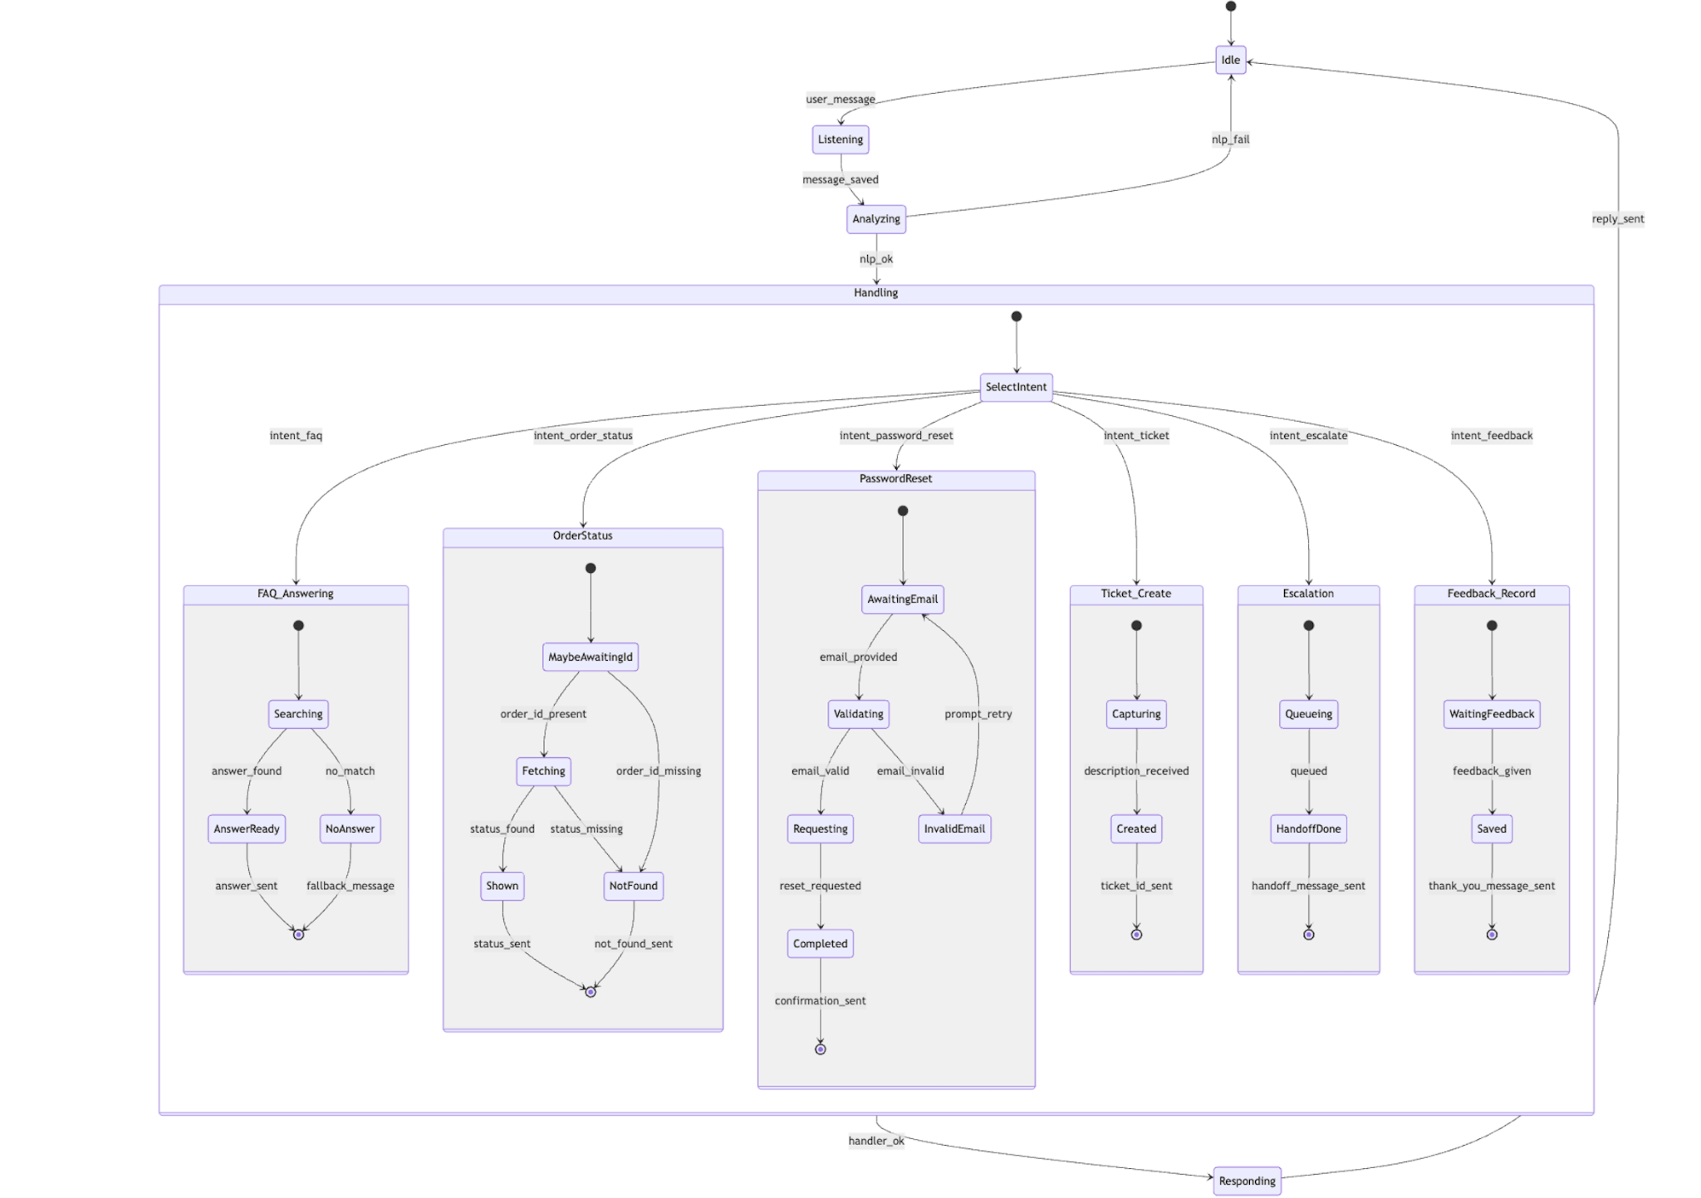

Task 2

1. Project Vision and Objectives
Vision:
To develop an intelligent customer support chatbot that automates responses to FAQs, order status checks, and password resets, while seamlessly escalating complex issues to human agents.
Objectives:
- Automate 70% of customer interactions using AI.
- Integrate APIs (Order, Email, Ticketing) for real-time information.
- Improve support response times and overall user satisfaction.
- Provide feedback-driven continuous improvement for chatbot accuracy.

2. Product Backlog (User Stories)
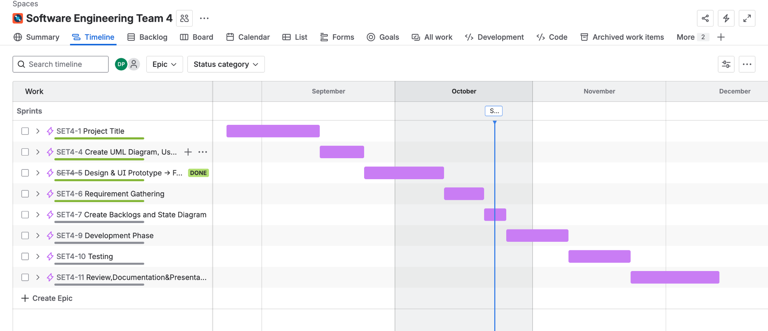

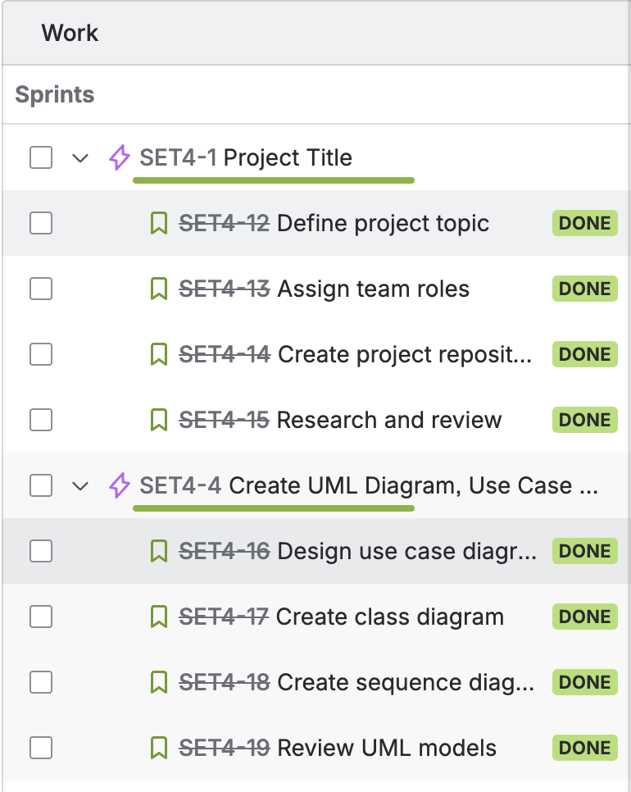
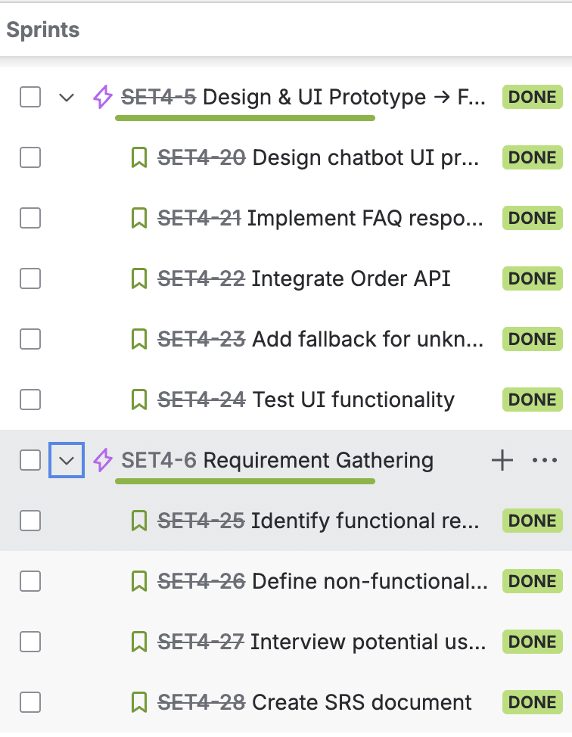

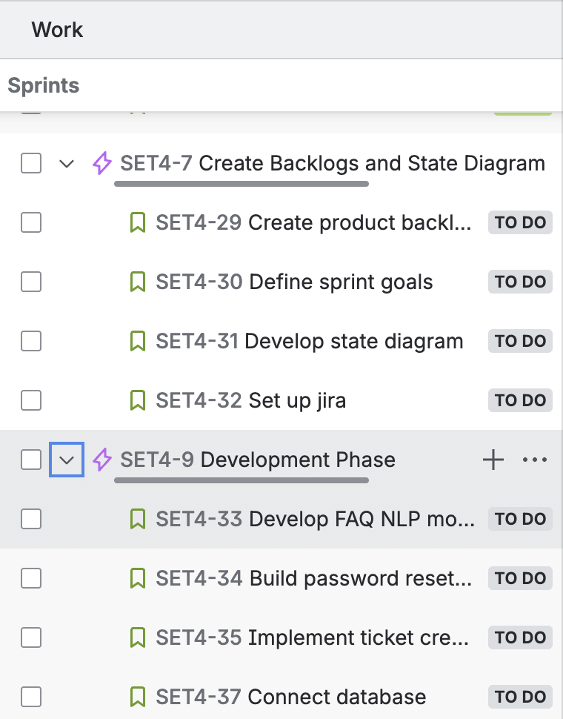
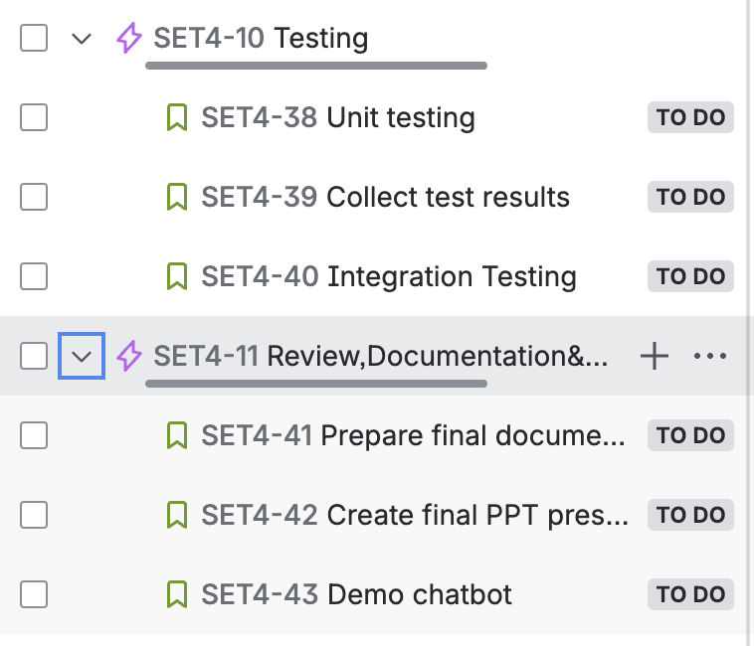

3.Sprint Planning
(define sprint duration and deliverables)
Current Sprint : Oct 12- Oct 25
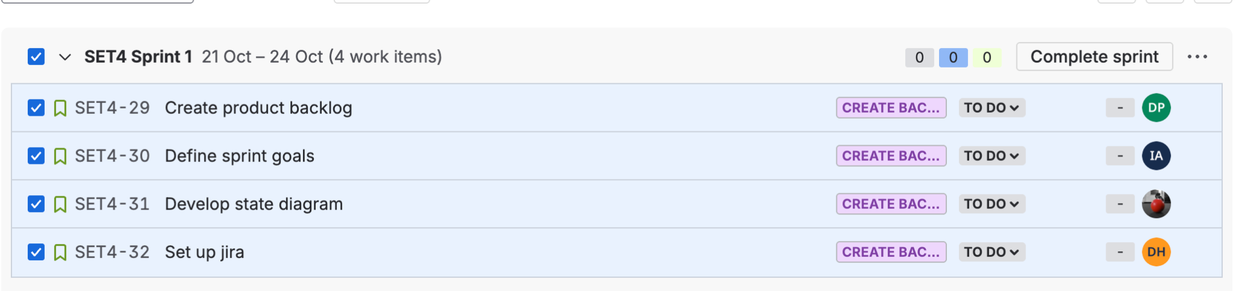
- Focused on setting up the Agile foundation for the AI-Powered Customer Support Chatbot project.
- Configured Jira workspace with Epics, Stories, and Scrum board for project tracking.
- Created the complete product backlog covering all chatbot modules — FAQ, Order API, Password Reset, Ticketing, Escalation, and Feedback.
- Defined clear sprint goals for upcoming iterations to ensure measurable progress.
- Developed the system state diagram to visualize chatbot flow and user transitions.
- All four tasks — Create product backlog, Define sprint goals, Develop state diagram, and Set up Jira — were completed and marked “Done.”
- Deliverables: Organized Jira board, finalized backlog and sprint plan, uploaded state diagram, and established Agile workflow for the team.
- This sprint successfully laid the foundation for design, development, and testing in future sprints.
4. Expected Deliverables per Iteration
- Sprint 1–2: Planning & Design → Documents, UML Diagrams, Jira Backlog.
- Sprint 3–4: Development & Integration → Chatbot Core Features.
- Sprint 5–6: Testing & Closure → Bug-free Build + Documentation.
Each sprint delivers a functional increment that can be demonstrated and reviewed, ensuring iterative progress and continuous feedback consistent with Agile Scrum methodology.

